**URDF Ankle-Pitch**

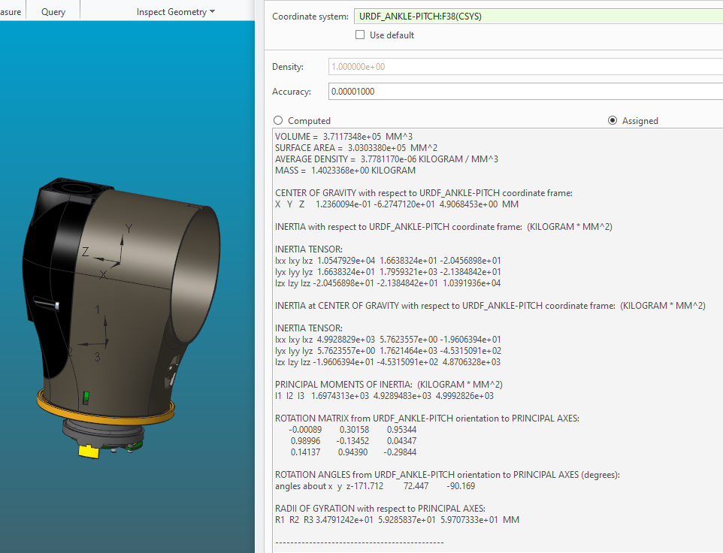

VOLUME = 3.7117348e+05 MM^3

SURFACE AREA = 3.0303380e+05 MM^2

AVERAGE DENSITY = 3.7781170e-06 KILOGRAM / MM^3

MASS = 1.4023368e+00 KILOGRAM

CENTER OF GRAVITY with respect to URDF_ANKLE-PITCH coordinate frame:

X Y Z 1.2360094e-01 -6.2747120e+01 4.9068453e+00 MM

INERTIA with respect to URDF_ANKLE-PITCH coordinate frame: (KILOGRAM * MM^2)

INERTIA TENSOR:

Ixx Ixy Ixz 1.0547929e+04 1.6638324e+01 -2.0456898e+01

Iyx Iyy Iyz 1.6638324e+01 1.7959321e+03 -2.1384842e+01

Izx Izy Izz -2.0456898e+01 -2.1384842e+01 1.0391936e+04

INERTIA at CENTER OF GRAVITY with respect to URDF_ANKLE-PITCH coordinate frame: (KILOGRAM * MM^2)

INERTIA TENSOR:

Ixx Ixy Ixz 4.9928829e+03 5.7623557e+00 -1.9606394e+01

Iyx Iyy Iyz 5.7623557e+00 1.7621464e+03 -4.5315091e+02

Izx Izy Izz -1.9606394e+01 -4.5315091e+02 4.8706328e+03

PRINCIPAL MOMENTS OF INERTIA: (KILOGRAM * MM^2)

I1 I2 I3 1.6974313e+03 4.9289483e+03 4.9992826e+03

ROTATION MATRIX from URDF_ANKLE-PITCH orientation to PRINCIPAL AXES:

-0.00089 0.30158 0.95344

0.98996 -0.13452 0.04347

0.14137 0.94390 -0.29844

ROTATION ANGLES from URDF_ANKLE-PITCH orientation to PRINCIPAL AXES (degrees):

angles about x y z-171.712 72.447 -90.169

RADII OF GYRATION with respect to PRINCIPAL AXES:

R1 R2 R3 3.4791242e+01 5.9285837e+01 5.9707333e+01 MM

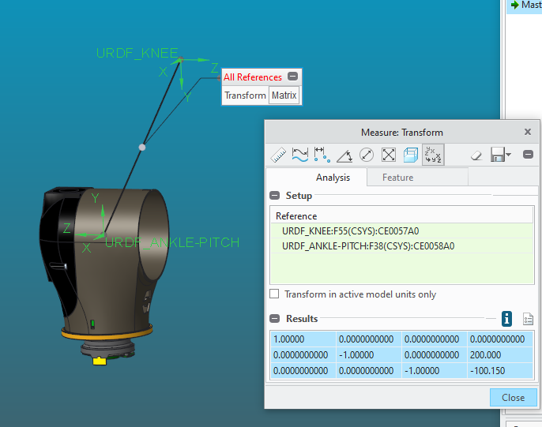

1.00000 0.0000000000 0.0000000000 0.0000000000

0.0000000000 -1.00000 0.0000000000 200.000

0.0000000000 0.0000000000 -1.00000 -100.150